**The French Revolution (1789-1815*) and Napoleon**

*\*this depends on whether you see Napoleon as a child of the French Revolution, honestly.*

|  |  |  |
| --- | --- | --- |
| **First Estate** | **Second Estate** | **Third Estate** |
|  |  | 98% of population |

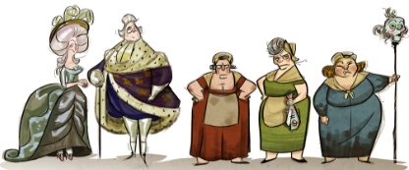 **- List four economic and social problems led to the outbreak of the Revolution.**

* **How did the American Revolution and the Enlightenment inspire the people of France?**

|  |  |
| --- | --- |
| What was the Estates General and why was it unpopular with the 3rd Estate? | How did court life at Versailles contribute to the unpopularity of Louis and Marie Antoinette? What was their punishment? |
| What was the National Assembly and how was it formed? *(hint: Tennis)* | What were the three ideals of the French Revolution? How were these reflected in the Declaration of the Rights of Man? |

**How did Robespierre & the mobs of Paris corrupt the Revolution? What happened in Paris from 1792-1794?**

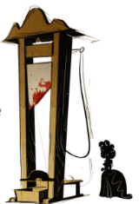

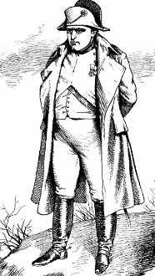**Napoleon (1799-1815*)**

**\****With interruptions*

How did Napoleon Bonaparte come to power?

|  |  |
| --- | --- |
| **Please highlight the countries controlled by France at the height of the Napoleonic Empire.**    **Napoleon controlled***: (list)* | How did Napoleon treat conquered armies and nations?  Why was Napoleon so popular with the people of France? (*be specific)* |
| Please share five provisions of the Napoleonic Code. | How did England react to Napoleonic expansion?  What is the Continental System, and why did Napoleon introduce it? |

**\* Post Napoleon – Concert of Europe and Isms (1815-1848)**

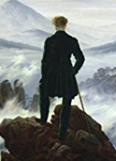

How did Napoleon finally fall from power?

What were the goals of the Congress of Vienna?

Leader?

* **What was the Concert of Europe?**

|  |  |  |  |
| --- | --- | --- | --- |
| **Types of Isms** | | | |
| **Conservativism** | **Liberalism** | **Romanticism** | **Nationalism** |
| Five ideals:  Leaders: | Five ideals:  Leaders: | Five ideals:  Artists: | Ideals:  Where do we see Nationalist movements in the early 1800’s? |

* **Please define or list the significance of the following**:
* Classicism-
* Lord Byron-
* Percy & Mary Shelley-
* Pre-Raphaelite Art-
* Florence Nightingale-
* Queen Victoria-
* Socialism-
* Flora Tristan-

|  |  |
| --- | --- |
| What was the cause of the Crimean War?  What lessons did Europe take from the war? | How were the Revolutions of 1848 a test of the ideals of Conservativism?  What was the general result of the revolts? |